DISTANCE EDUCATION
DE–5826
13
M.Sc. DEGREE EXAMINATION, MAY 2009.
Mathematics
DIFFERENTIAL EQUATION AND NUMERICAL METHODS
Time : Three hours Maximum : 100 marks
Answer any FIVE questions.
All questions carry equal marks.
1. (a) Prove that there exist linearly independent solution of 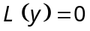 on .
(b) Find two linearly independent solutions of the equation 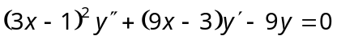.
2. Derive Bessel equation.
3. Deduce the methods of integrating the equations of the four standard forms of Charpit’s method.
4. (a) Find the integral surface of the linear partial differential equation .
(b) Reduce the equation 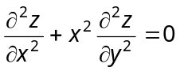 to canonical form.
5. (a) Find the multiple root of the equation using Newton’s Method.
(b) Obtain the least square polynomial approximation of degree 1 and 2 for 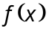= 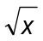 on 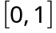.
6. (a) Derive uniform polynomial approximation.
(b) Using Chebyshev polynomials obtain the least squares approximation of second degree for 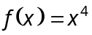 on 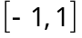.
7. Explain the Gauss-Hermite interpolation methods with examples.
8. (a) Solve the boundary value problem 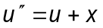, 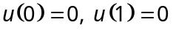 with 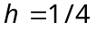. Use Numerov Method in the interval .
(b) Solve the boundary value problem :
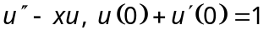, 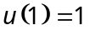, with 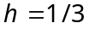 use the second order method.
————————
DISTANCE EDUCATION
DE–5825
12
M.Sc. DEGREE EXAMINATION, MAY 2009.
Mathematics
REAL ANALYSIS
Time : Three hours Maximum : 100 marks
Answer any FIVE questions.
All questions carry equal marks.
1. (a) Prove that for any collection 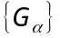 of opensets 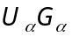 is open.
(b) Prove that closed subsets of compact sets are compact.
2. (a) State and prove Heine Borel covering theorem.
(b) State and prove the Bolzano Weierstrass theorem.
3. (a) Explain the chain rule.
(b) State and prove Rolle’s theorem.
4. (a) Explain Taylor’ formula with remainder.
(b) State and prove the implicit function theorem.
5. (a) Suppose 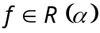 on 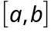, 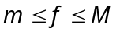, is continuous on 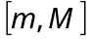 and 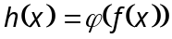 on . Then prove 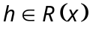 on .
(b) Prove that 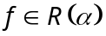 on if and only if for every 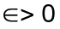 their exists a partition p such that 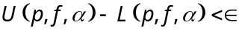.
6. (a) If and 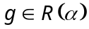 on then prove that
(i) 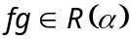
(ii) 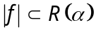 and 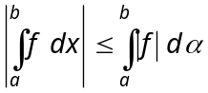.
(b) Assume increases monotonically and 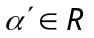 on . Let f be a bounded real function on . Then prove 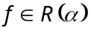 if and only if f . In that case 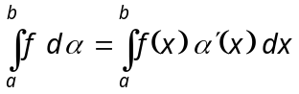.
7. Prove that
(a) For every 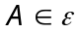, 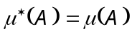.
(b) If 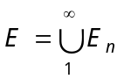then 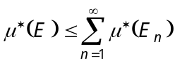.
8. State and prove Egoroff’s theorem.
—————————
DE–5824
11
DISTANCE EDUCATION
M.Sc. (Mathematics) DEGREE EXAMINATION, MAY 2009.
ALGEBRA
Time : Three hours Maximum: 100 marks
Answer any FIVE questions.
All questions carry equal marks.
1. (a) Prove that  is a normal subgroup of  if and only if 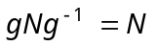 for every 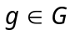.
(b) Prove that the number of p-Sylow subgroups in
equals 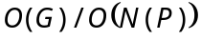, where 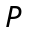 is any -Sylow subgroup of . In particular this number is a divisor of 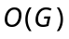.
2. (a) Let be 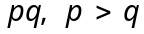 are prime, prove that any two non-abelian groups of order 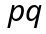 are isomorphic.
(b) Prove that every permutation is a product of
2-cycles.
3. (a) Prove that if  is any field which contains  then contains a sub field isomorphic of 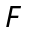.
(b) Let 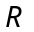 be a Euclidean ring. Then every element in is either a unit in or can be written as the product of a finite number of prime elements of .
4. State and prove unique Factorization theorem.
5. (a) Prove that if  is finite-dimensional over then is isomorphic to 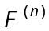 for a unique integer , in fact, is the number of elements in any basis of over .
(b) If  and 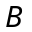 are finite dimensional subspaces of a vector space , then  is finite dimensional and
dim .
6. (a) Prove that the linear transformation 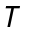 on is unitary if and only if it takes an orthonormal basis of into an orthonormal basis of .
(b) If 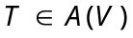 is Hermitian, then all its characteristics roots are real.
7. (a) If is a field and if 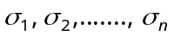 are distinct automorphisms of then it is impossible to find elements 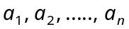, not all 0 , in such that
for all 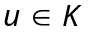
(b) Prove that 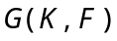 is a subgroup of the group of all automorphism of .
8. (a) Prove that a polynomial of degree over a field can have atmost roots in any extension field.
(b) If is a prime number, prove that the spliting field over , the field of rational numbers of the polynomial 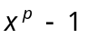 is of degree 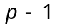.
–––––––––––––––
DE–5833
25
DISTANCE EDUCATION
M.Sc. (Mathematics) DEGREE EXAMINATION, MAY 2009.
DISCRETE AND COMBINATORIAL MATHEMATICS
Time : Three hours Maximum : 100 marks
Answer any FIVE questions.
Each question carries 20 marks.
1. (a) Solve 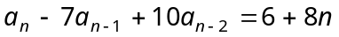, 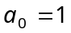 and 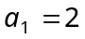.
(b) Find the recurrence relation satisfying 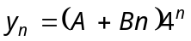.
2. (a) Using the generating function technique solve the relation 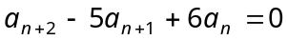, 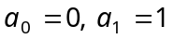.
(b) Find the number of n-digit binary sequences that have the pattern 010 occurring at the n^{th} digit.
3. (a) Obtain the number of derangements of n objects using a recurrence relation.
(b) Find the number of integers between 1 and 250 that are not divisible by any of the integers 2, 3, 5 and 7.
4. (a) Find the number of permutations of the letters 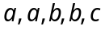 and so that no a appears in the first and second position, no b appears in the third position and no c appears in the fifth and sixth positions.
(b) State and prove the principle of inclusion and exclusion.
5. (a) Let be a finite set and let be a permutation group of . For 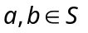, is related b if there is a permutation in G such that 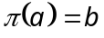. Show that this relation is an equivalence relation.
(b) State and prove Burnside lemma.
6. (a) Find the cycle index of the permutation group 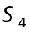.
(b) Write notes on pattern inventory.
7. (a) Define modular lattice. Show that every chain is a modular lattice.
(b) Define distributive lattice. Give an example of a modular lattice which is not distributive.
(c) Show that the product of two distributive lattice is a distributive lattice.
8. (a) Find the principle disjunction normal form of 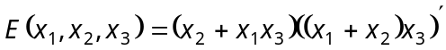.
(b) Define Boolean algebra and give an example. Also give an example of a lattice which is not a Boolean algebra.
(c) Write the minimization algorithm for Boolean function for 4 variable k-map.
–––––––––––––––
DE–5832
24
DISTANCE EDUCATION
M.Sc. (Maths) DEGREE EXAMINATION, MAY 2009.
PROGRAMMING IN C/C++
(2008 onwards)
Time : Three hours Maximum: 100 marks
Answer any FIVE questions.
All questions carry equal marks.
1. (a) Distinguish between C and C++. (8)
(b) What are the different data types available in C? (12)
2. (a) Explain about the formatted input and outputs statements. (10)
(b) What is an operator? What are the different types of operators in C? Explain. (10)
3. (a) Explain the basic concepts of object oriented programmings. (12)
(b) Discuss switch and while statements with examples. (8)
4. (a) Write a C program to multiply two 3 × 3 matrices.
(10)
(b) Describe any four string handling functions. (10)
5. (a) Write a C program to count the number of vowels in a given sentence. (10)
(b) Explain the following with examples :
(i) Extern. (5)
(ii) Static. (5)
6. (a) Write a C program to solve the quadratic equation.
(10)
(b) How do you declare and initialize structures? Explain. (10)
7. (a) What is pointer? Explain about pointer initialization and declaration. (10)
(b) Write a program to interchange two numbers using pointers. (10)
8. (a) What are the different input and output statements in files? Explain. (10)
(b) Write a program that gets different numbers and store in an input file. Read the input file, the odd numbers are stored in ODD file, the even numbers are stored in EVEN file.
(10)
–––––––––––––––
DISTANCE EDUCATION
DE–5831
23
M.Sc. DEGREE EXAMINATION, MAY 2009.
Mathematics
GRAPH THEORY
Time : Three hours Maximum : 100 marks
Answer any FIVE questions.
All questions carry equal marks.
1. (a) Define bipartite graph and the term cycle.
(b) Prove that a graph is bipartite if and only if it contains no odd cycle.
(c) Let be a graph without loops. Then prove that
is a tree if and only if any two vertices of are connected by a unique path.
2. (a) Define a tree and draw a graph which is tree and a graph which is not tree.
(b) Prove that an edge of is a cut edge of if and only if is contained in no cycle of .
(c) Define complete graph and prove that for a complete graph 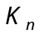, 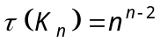.
3. (a) Define vertex connectivity and edge connectivity of a graph .
(b) Prove that for any graph , the vertex connectivity the edge connectivity the minimum degree.
(c) Define block. And prove that if is a block with 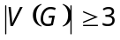, then any two edges of lie on a common cycle.
4. (a) Define Hamiltonian graph. Prove that 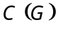, the closure of , is well defined.
(b) Give an example for hamiltonian graph and non hamiltonian graph.
(c) Prove that a connected graph is eulerian if and only if it can be decomposed into cycles.
5. (a) Prove that a subset of 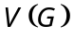 is an independent set if and only if 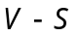 is a covering of .
(b) Find 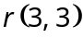 and 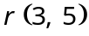.
(c) Prove that 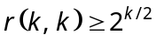.
6. (a) Prove that for any positive integer , there exists a K-chromatic graph containing no triangle.
(b) Find the chromatic polynomial of the following graph 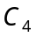:

7. (a) If is a connected plane graph, then prove that 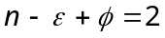.
(b) If is a simple planar graph, then prove that 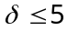.
(c) Prove that the graph 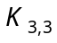 is non-planar.
8. (a) Prove that a diagraph contains a directed path of length 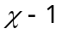.
(b) State and prove the Max-flow Min-cut theorem.
——————————
DISTANCE EDUCATION
DE–5830
22
M.Sc. DEGREE EXAMINATION, MAY 2009.
Mathematics
TOPOLOGY AND FUNCTIONAL ANALYSIS
Time : Three hours Maximum : 100 marks
Answer any FIVE questions.
Each question carries 20 marks.
1. (a) Let  be a non-empty set, and consider the class of subsets of consisting of the empty set and all sets whose complements are countable. Is this a topology on ? Justify your answer.
(b) Show that a subset of a topological space is dense it intersects every non-empty open sets.
(c) Prove that any continuous image of a compact space is compact.
2. (a) Show that every compact metric space has the Bolzano-Weierstrass property.
(b) Prove that every sequentially compact metric space is compact.
(c) Prove that any continuous mapping of a compact metric space into a metric space is uniformly continuous.
3. (a) Prove that a closed subspace of a normal space is normal.
(b) State and prove the Urysohn Imbedding theorem.
4. (a) Prove that the product of any non-empty class of connected spaces in connected.
(b) Let X be a topological space and A be a connected subspace of X. Prove that 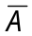 is connected.
(c) If 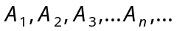 is a sequence of connected subspaces of a topological space each of which intersects its successor, show that 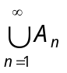 is connected.
5. (a) State and prove  inequality.
(b) Let be a linear subspace of a real normed linear space , and let be a functional defined on M. If 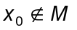 and if 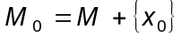 is a linear subspace spanned by and 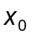, then prove that can be extended to a functional 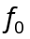 defined on 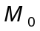 such that 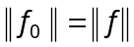.
6. (a) State and prove open mapping theorem.
(b) State and prove the Uniform Boundedness Theorem.
7. (a) Prove that a closed convex subset C of a Hilbert space H contains a unique vector of smallest norm.
(b) State and prove Bessel’s inequality.
(c) If M is proper closed linear subspace of a Hilbert space H, then prove that there exists a non-zero vector 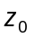 in H such that 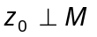.
8. (a) Let H be a Hilbert space, and let be an arbitrary functional in 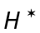. Prove that there exists unique vector in 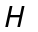 such that 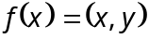 for every in .
(b) Prove that the adjoint operation 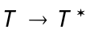 on 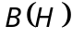 has the following properties :
(i) 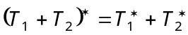,
(ii) 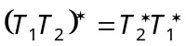,
(iii) 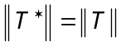.
––––––––––––––
21
DE-5829
DISTANCE EDUCATION
M.Sc. (Mathematics) DEGREE EXAMINATION, MAY 2009.
COMPLEX ANALYSIS
Time : Three hours Maximum : 100 marks
Answer any FIVE questions.
All questions carry equal marks.
(5 × 20 = 100)
1. (a) Write a short note on stereographic projection.
(b) Find the complex number represented by the given point 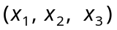 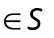 where S is the unit sphere with the centre origin.
(c) Derive the C-R equations in polar coordinates.
2. (a) Prove that every power series represents an analytic function at all points within the circle of convergence and its derivatives can be obtained by term wise differentiation of the given power series.
(b) Discuss the mapping .
3. (a) If 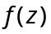 is a function, which is analytic inside and on a simple closed curve C and if is any point in the interior of C, prove that 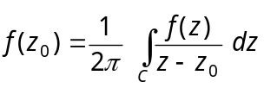.
(b) Evaluate 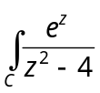 dz where C is positively oriented circle 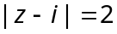.
4. (a) State and prove Liouville's theorem.
(b) State and prove Morera's theorem.
(c) Expand 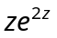 in a Taylor's series about 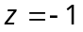 and determine the region of convergence.
5. (a) State and prove Laurent's theorem.
(b) Determine and classify the singular points of 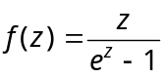.
6. (a) State and prove Mittag-Leffler theorem.
(b) If f is an entire function and 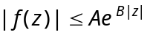 where A and B are constants, 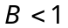 and if f have zeros 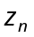 with 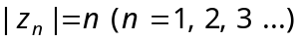 then prove that 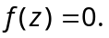
7. (a) State and prove Rouche's theorem.
(b) State and prove Legendre's duplication formula.
8. (a) Show that any elliptic function with period 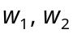 can be written as 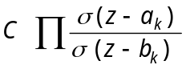 where C is a constant.
(b) State and prove Cauchy's Residue theorem.

———————
DE–5828
15
DISTANCE EDUCATION
M.Sc. (Mathematics) DEGREE EXAMINATION, MAY 2009.
MATHEMATICAL STATISTICS
Time : Three hours Maximum : 100 marks
Answer any FIVE questions.
(5 × 20 = 100)
1. (a) S.T. the function 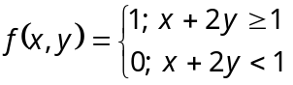 can not be a distribution function of two random variables.
(b) State and prove ‘‘Chebyshev’s inequality’’.
(c) If 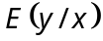 is a linear then the conditional variance of y given 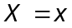 is 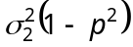. Deduce that 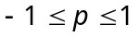.
2. (a) Find the M.G.F of Gamma distribution and also find its mean and variance.
(b) State and prove ‘‘Central limit theorem’’.
3. (a) Let 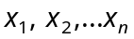 be a random sample from the exponential distribution with probability density function 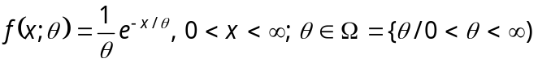. Find the maximum likelihood estimator force.
(b) Let two random samples, each of size 10, from two independent normal distribution 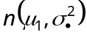 and 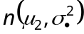 yield 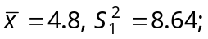 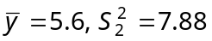. Find a 95% confidence interval for 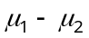.
4. (a) State and prove law of large numbers.
(b) Explain the properties of ‘‘Good Estimator’’.
5. (a) From the following data obtained from a sample of 1000 persons, calculate standard error of mean.
Salary : | 0-10 | 10-20 | 20-30 | 30-40 | 40-50 | 50-60 | 60-70 | 70-80
Workers. : | 50 | 100 | 150 | 200 | 200 | 100 | 100 | 100
Is it likely that the sample has come from the population with an average weekly earnings of Rs. 4,200.
(b) State and prove ‘‘Neyman-Pearson theorem’’.
6. (a) Find the critical region of the Likelihood ratio test for testing the null hypothesis 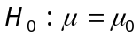 against the composite alternative 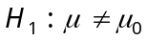 on the basis of a random sample size n from a normal population with the known variance 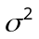.
(b) Intelligence test on two groups of boys and girls gave the following results.
 | Mean | S.B. | Sample size
Girls : | 75 | 15 | 150
Boys : | 70 | 20 | 250
Is there a significant difference in the mean scores obtained by boys and girls?
7. (a) Discuss the 3 types of acceptance sampling plans.
(b) For the sampling Plan N = 1200, n = 64, c = 1.
Determine the probability of acceptance of the following lots;
(i) 0.5% defective
(ii) 0.8% defective
(iii) 1% defective
(iv) 2% defective
(v) 4% defective
(vi) 10% defective.
Also draw an OC curve.
8. (a) What is classification? Explain the types of classification?
(b) 3 varieties of coal were analysed by 5 chemists and the ash content in the varieties was found to be as under :
 | Chemist
Variety | I | II | III | IV | V
A | 9 | 7 | 6 | 5 | 8
B | 7 | 4 | 5 | 4 | 5
C | 6 | 5 | 6 | 7 | 6
Do the varieties differ significance in their ash content?

———————
DISTANCE EDUCATION
DE–5827
14
M.Sc. DEGREE EXAMINATION, MAY 2009.
Mathematics
OPERATIONS RESEARCH
Time : Three hours Maximum : 100 marks
Answer any FIVE questions.
(5 × 20 = 100)
1. (a) Solve the following Linear programming problem graphically :
Maximize 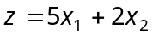
Subject to 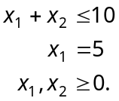
(b) Solve by Simplex method.
Maximize 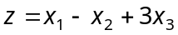
Subject to 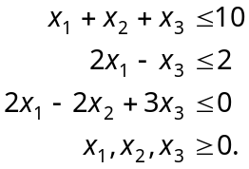
2. (a) Write the dual of the linear programming problem.
Minimize 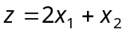
Subject to 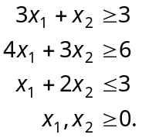
(b) Solve the following Linear programming problem using dynamic programming :
Maximize 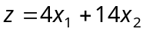
Subject to 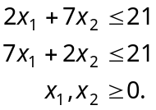
3. (a) A farmer wants to decide which of the three crops he should plant on his 100 acre farm. The profit from each is dependent on the rainfall during the growing season. The farmer has categorized the amount of rainfall as high, medium and low. His estimated profit for each crop is shown in the table below :
Rainfall | Estimated conditional profit (Rs.)
 | Crop A | Crop B | Crop C
High | 8000 | 3500 | 5000
Medium | 4500 | 4500 | 5000
Low | 2000 | 5000 | 4000
If the farmer wishes to plant only one crop, decide which should be his ‘best crop’ using
(i) Maximum criterion
(ii) Minimax regret criterion
(iii) Laplace criterion
(iv) Hurwicz criterion.
(b) Solve the following game graphically.
 |  | Player B
 |  | 1 | 2
 | 1 | 2 | 4
Player A | 2 | 2 | 3
 | 3 | 3 | 2
 | 4 | –2 | 6
4. (a) Obtain Wilson’s economic lot size formula.
(b) A company has a steady demand of a product of
40 items per month. The purchase cost is Rs. 6 per item and the cost of ordering and procuring the material is Rs. 15 per occasion. If stock holding cost is 20% per annum, how frequency should the company replenish the stock?
5. (a) Construct the arrow diagram comprising activities A, B, C ... L such that the following relationships are satisfied.
(i) A, B and C, the first activities of the project can start simultaneously
(ii) A and B precede D
(iii) B precede E, F and H
(iv) F and C precede G
(v) E and H precede I and J
(vi) C, D, F and J precede K
(vii) K precede L
(viii) If I, G and L are the terminal activities.
(b) Compute the total and free floats for the critical and non-critical activities in the following network.
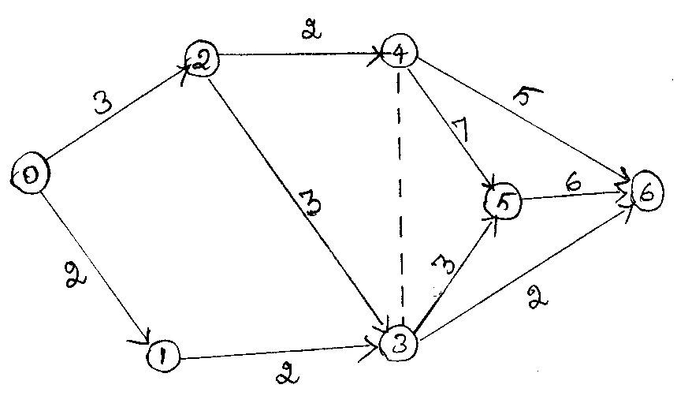
6. (a) Find the critical path for the following project :
Activity  (i, j) | Estimated  times  (a, b, m) | Activity  (i, j) | Estimated  times  (a, b, m)
(0, 1) | (1, 3, 2) | (3, 5) | (1, 7, 2.5)
(0, 2) | (2, 8, 2) | (3, 6) | (1, 3, 2)
(1, 3) | (1, 3, 2) | (4, 5) | (6, 8, 7)
(2, 3) | (1, 11, 1.5) | (4, 6) | (3, 11, 4)
(2, 4) | (0.5, 7.5, 1) | (5, 6) | (4, 8, 6)
(b) Find the different minimum-cost schedules that can occur between normal and crash times in the following table.
Activity  (i, j) | Normal |  | Crash
 | Duration | Cost | Duration | Cost
(1, 2) | 8 | 100 | 6 | 200
(1, 3) | 4 | 150 | 2 | 350
(2, 4) | 2 | 50 | 1 | 90
(2, 5) | 10 | 100 | 5 | 400
(3, 4) | 5 | 100 | 1 | 200
(4, 5) | 3 | 80 | 1 | 100
7. (a) Solve the following four-period deterministic inventory problem.
Period  i | Demand  D_{i} | Set up cost  K_{i} | Holding cost  h_{i}
1 | 5 | 5 | 1
2 | 7 | 7 | 1
3 | 11 | 9 | 1
4 | 3 | 7 | 1
The purchasing cost per unit is 1 for the first six units and 2 for any additional units.
(b) A departmental store has a single cashier. During the rush hours, customers arrive at a rate of 20 customers per hour. The average number of customers that can be processed by the cashier is 24 per hour. Assume that the conditions for use of the single-channel queueing model apply.
(i) What is the probability that the cashier is Idle?
(ii) What is the average number of customers in the queueing system?
(iii) What is the average time a customer spends in the system?
(iv) What is the average number of customers in the queue?
(v) What is the average time a customer spends in the queue waiting for service?
8. (a) Explain the Queueing model.
(M/M/C) : (GD/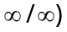.
(b) A small town is being serviced by two cab companies. Each of two companies owns two cabs and are known to share the market equally. This is evident by the fact that calls arrive at each company is dispatching office at the rate of 10 per hour. The average time per ride is 11.5 minutes. Arrival of calls follows a Poisson distribution wherever ride times are exponential.
(i) Prove that the utilization factor when the two dispatching offices remain unconsolidated is equal to the utilization factor in the unconsolidated facility.
(ii) Show that the expected waiting time until a cab is dispatched to the customer is cut by 50% when consolidating the two companies.

————————

